# Lab 2: Microprocessor & Assembly Language

## Add the 16-bit number in memory location 4000H and 4001H to the 16-bit number in memory location 4002H and 4003H. The most significant eight bits of the two numbers to be added are in memory location 4001H and 4003H. Store the result in memory locations 4004H and 4005H with the most significant byte in memory location 4005H.

### Santosh one

LDA 4000H

MOV B,A

LDA 4001H

MOV C, A

LDA 4002H

MOV D,A

LDA 4003H

MOV E,A

MOV A, C

ADD E

STA 4005H

MOV A, B

ADD D

STA 4004H

HLT

### Salim one

LDA 4000

MOV E,A

LDA 4001

MOV D,A

LDA 4002

MOV C,A

LDA 4003

MOV B,A

MOV A,E

ADD C

MOV L,A

MOV A,D

ADD B

MOV H,A

MOV A,L

STA 4004

MOV A,H

STA 4005

HLT

Output

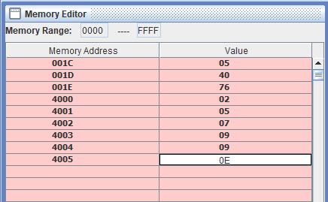

## 2. Subtract the 16-bit number in memory locations 4002H and 4003H from the 16 bit number in memory locations 4000H and 4001H. Store the result in memory locations 4004H and 4005H with the most significant byte in memory location 4005H.

LDA 4000

MOV E,A

LDA 4001

MOV D,A

LDA 4002

MOV C,A

LDA 4003

MOV B,A

MOV A,E

SUB C

MOV L,A

MOV A,D

SUB B

MOV H,A

MOV A,L

STA 4004

MOV A,H

STA 4005

HLT

Output

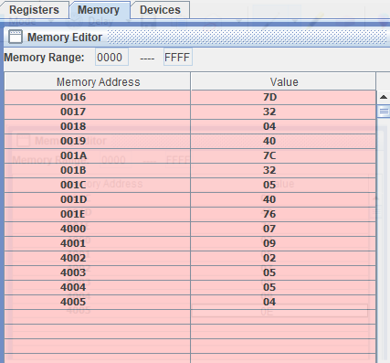

## 3. Write a program to shift eight-bit data four bits right. Assume that the data is in register C.